Article
CASDA: Enhancing Steel Defect Detection through Context-Aware Data Augmentation Framework
Ho-Jun Han and Il-Young Moon *
Citation: To be added by editorial staff during production.
Academic Editor: Firstname Lastname
Received: date
Revised: date
Accepted: date
Published: date

Copyright: © 2024 by the authors. Submitted for possible open access publication under the terms and conditions of the Creative Commons Attribution (CC BY) license (https://creativecommons.org/licenses/by/4.0/).
School of Computer Science and Engineering, Korea University of Technology and Education, Cheonan 31253,
Republic of Korea
* Correspondence: iymoon@koreatech.ac.kr; Tel: +82-41-560-1493
Abstract: Defect detection in manufacturing has evolved from manual inspection to deep learning-based Automated Visual Inspection (AVI) systems; however, acquiring sufficient defect samples in real industrial environments remains challenging, causing severe data sparsity and class imbalance. We propose CASDA (Context-Aware Steel Defect Augmentation), a five-stage framework that classifies defect morphology and background surface properties, constructs a compatibility matrix encoding their contextual relationship, and synthesizes defect images via a ControlNet pipeline conditioned on a three-channel hint image. Experiments on the Severstal steel dataset demonstrate that CASDA achieves an 83.0% quality validation pass rate. Under multi-seed evaluation (seeds 42 and 456), CASDA improved EB-YOLOv8 overall mAP@0.5 by 2.60 pp over the raw baseline and achieved a Class 2 AP gain of 22.09 pp over Copy-Paste, suggesting that context-aware synthesis produces more discriminative minority-class training samples than simple patch reuse under the tested settings. Performance gains are architecture-dependent; YOLO-MFD did not show overall improvement, indicating that augmentation sensitivity varies with backbone feature representation.
Keywords: Defect detection; Data augmentation; ControlNet; Stable Diffusion; Steel manufacturing; Deep learning

1. Introduction
With the advent of the Fourth Industrial Revolution, defect detection in manufacturing processes has rapidly shifted from manual inspection to deep learning-based Automated Visual Inspection (AVI) systems [1]. These systems have demonstrated high performance across industrial sectors such as steel, textiles, and semiconductors, establishing themselves as a core technology for quality control. However, deep learning-based defect detection models rely heavily on large-scale, high-quality training data, limiting their applicability in data-scarce industrial settings [2].
In real-world industrial environments, collecting sufficient defect samples is inherently challenging because defects occur infrequently and exhibit diverse shapes, sizes, and patterns [3]. The resulting scarcity of minority-class defect data causes severe class imbalance, which degrades model generalization performance [4]. While existing augmentation techniques—such as geometric transformations and color variations—partially improve data diversity, they fail to capture the unique structural characteristics of defects or their contextual relationships with the background [5].
To address this gap, data augmentation methods based on generative models have been actively investigated. Generative Adversarial Networks (GANs) and diffusion-based models have shown promising results in synthesizing defect images [6, 7]. However, existing approaches do not adequately model the spatial and physical consistency between defects and their background substrate, producing unrealistic samples that fail to reflect actual defect characteristics. This paper proposes CASDA (Context-Aware Steel Defect Augmentation), a framework designed to overcome data sparsity and class imbalance in industrial defect inspection by generating realistic defect images that respect the structural relationship between defect morphology and the background surface.
The methodology proceeds through the following stages. First, defect types are systematically classified based on morphological and statistical indicators. Background surface characteristics are simultaneously analyzed and categorized. A compatibility matrix is then constructed to quantify defect–background relationships and used as a condition to generate contextually consistent images via a ControlNet-based generative model. Finally, the generated defects are naturally composited onto normal surface images to expand dataset diversity.
The proposed framework introduces a context-aware augmentation paradigm that integrates background consistency into the defect synthesis process. The novelty lies not in any individual technique but in the task-specific design of their interactions: the 3-channel hint image encodes defect texture, background orientation, and binary mask jointly in a single conditioning signal; the compatibility matrix constrains background selection to semantically consistent substrates; and Poisson blending is applied as a domain-gap reduction mechanism rather than a cosmetic post-processing step. A full component-level ablation study confirms that each of these design choices contributes measurably to downstream detection performance. Experimental results indicate that the benefit of CASDA is architecture-dependent, with consistent gains observed for EB-YOLOv8 and limited improvement for YOLO-MFD, suggesting that the interaction between augmentation strategy and backbone feature representation warrants further investigation.
2. Related Work
2.1. Industrial Defect Detection
Deep learning-based industrial defect detection has primarily evolved around supervised learning-based object detection or segmentation models [8, 9]. Recently, one-class anomaly detection approaches that detect anomalies using only normal data have also been actively investigated [10]. While these methods are attracting attention as alternatives given the limitations of data collection in real industrial environments, they remain limited in detecting minute or diverse defect types. In particular, model performance invariably degrades when sufficient defect data is unavailable [11].
2.2. Data Augmentation.
Various data augmentation techniques have been proposed to mitigate data sparsity. Traditional geometric transformations and color-based augmentation are simple to implement and widely used, but they fail to reflect the structural characteristics of defects [5]. To address this, cut-paste-based synthesis techniques or methods for recombining defect regions have been proposed; however, ensuring natural alignment between defects and the background remains challenging [12].
2.3. Generative Models for Augmentation
GANs and diffusion-based generative models have been increasingly applied to defect image generation. While these methods effectively expand data diversity, synthesized defects do not sufficiently reflect the physical characteristics of real industrial environments [4]. In particular, because spatial and contextual relationships between defects and the background are not explicitly modeled, unrealistic samples may result.
2.4. Condition-based generation and ControlNet
Research on conditional image generation has been actively pursued. In particular, ControlNet is capable of precisely controlling image generation based on structural conditions and has been applied across various domains [13]. However, existing work has primarily focused on general image generation or style control, and explicit modeling of the defect-background relationship in industrial defect augmentation remains limited [4].

2.5. Data-Driven Augmentation for Industrial Inspection
Data-driven augmentation has emerged as a key strategy for overcoming defect sample scarcity in industrial settings. GAN-based methods first demonstrated that realistic synthetic defects could be generated from limited labeled data [6], while denoising diffusion probabilistic models (DDPMs) have since offered superior sample diversity and visual fidelity across steel, textile, and PCB domains [7]. However, a common limitation of prior methods is that defect generation is conditioned on defect appearance alone, without explicit modeling of the background surface, causing synthesized defects to exhibit texture or intensity distributions incompatible with the target substrate [4]. CASDA addresses this gap through a compatibility matrix and 3-channel hint image that jointly encode defect morphology and background surface properties.

2.6. Aware Data Augmentation for Defect Detection
A dedicated line of research has developed augmentation strategies explicitly designed to respect the structural and contextual properties of industrial defect images, distinguishing themselves from domain-agnostic augmentation pipelines. Weimer et al. [19] demonstrated that GAN-based synthetic defect generation, when applied to the NEU steel strip dataset, can measurably improve detection accuracy for rare defect classes without requiring additional real-world data collection, establishing the core value proposition of synthetic augmentation for class-imbalanced defect datasets. More recent work has leveraged latent diffusion models to address few-shot defect generation scenarios: a diffusion-based approach applied to steel surface inspection [20] employs low-rank embedding adaptation and a mask-guided defect learning mechanism to fine-tune a pre-trained stable diffusion model on a small set of target-domain defect images, achieving significant improvement in detection recall for minority defect classes under data-scarce conditions. Complementary to generation-focused methods, context-aware synthetic augmentation approaches incorporate residual refinement modules and tailored training strategies that enforce coherence between the synthesized defect and the surrounding background texture [21]. Collectively, these works confirm that awareness of the defect-background relationship during synthesis—whether through GAN conditioning, diffusion model fine-tuning, or inpainting loss design—consistently improves the downstream utility of synthetic samples compared to context-agnostic generation. CASDA contributes to this line of work by formalizing the defect-background relationship through an explicit compatibility matrix and a 3-channel hint image, providing a structured and auditable conditioning mechanism that generalizes across defect morphological subtypes and background surface categories.
3. Methodology
3.1. Experimental Setup
The Severstal Steel Defect Detection dataset was used to evaluate the proposed method [14]. The dataset contains multiple defect classes with distinct morphological characteristics and occurrence patterns, exhibiting a class-imbalanced distribution across normal and defect images. In particular, while most defect classes have sufficient samples, Class 2 is severely underrepresented, resulting in pronounced data sparsity. This imbalanced distribution, common in real industrial environments, is a primary driver of detection performance degradation for minority classes. The dataset therefore provides a suitable testbed for evaluating the effectiveness of the proposed CASDA framework under data sparsity and class imbalance conditions.
3.2. CASDA Pipeline
The CASDA (Context-Aware Steel Defect Augmentation) framework consists of a five-stage sequential pipeline designed to preserve the geometric characteristics of defects and the physical context of the background. The five stages are: defect characteristic analysis, ControlNet configuration, context-based synthesis, quality verification, and dataset integration.
Figure1. CASDA Pipeline
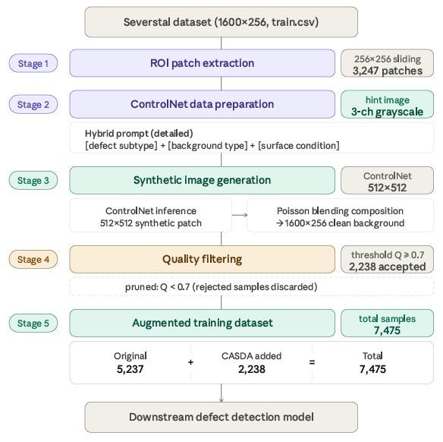
3.2.1 Stage 1: Geometric ROI Characterization and Suitability Evaluation
First, the Region of Interest (ROI) is extracted from the original dataset, and four geometric indicators are calculated to quantify the morphological characteristics of the defects.
The linearity index was computed by performing eigenvalue decomposition of the covariance matrix derived from the pixel coordinate set of the defect mask [15].
Linearity $λ=\frac{λ_{max}-λ_{min}}{λ_{max}+λ_{min}}$ | (1)
The solidity of the defect region was defined as the ratio of the actual defect area to the area of its convex hull and was used to quantify defects with irregular boundaries [16].
Solidity $σ=\frac{A_{defect}}{A_{convex_hull}}$ | (2)
The area ratio (fill ratio or extent) was defined as the ratio of the defect area to the area of its bounding box and serves as a classical shape descriptor for measuring the rectangularity of a region [17].
$Area Ratio ε=\frac{A_{defect}}{A_{bounding_box}}$ | (3)
An ellipse was fitted to the defect region using the least-squares method, and the ratio of the major to minor axis was defined as the aspect ratio [18].
$Aspect Ratio α=\frac{major_axis}{minor_axis}$ | (4)
Defects are classified into linear_scratch, irregular, compact_blob, or general types based on the following criteria:
Table 1. Defect type classification
$defect type=\{linear scratch, ifλ>0.85 and α>5.0 irregular, if σ<0.7 compact blob, if α<2.0 and σ>0.9 general, otherwise$

Figure2. Geometric ROI characterization pipeline
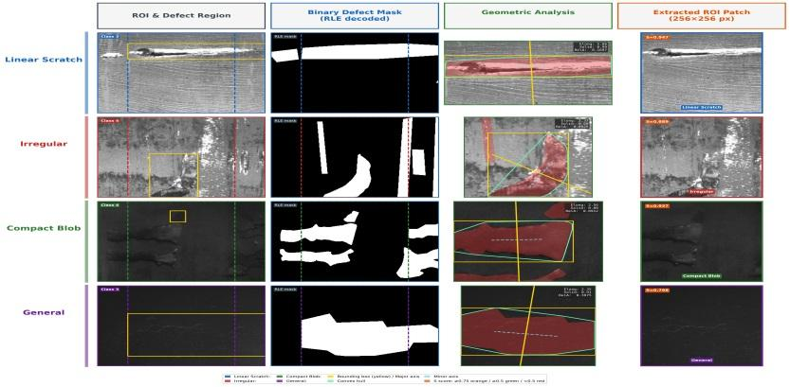
Each row corresponds to a defect subtype (Linear Scratch, Irregular, Compact Blob, and General), and each column represents a successive processing step: (1) the steel image crop with the ROI window and defect bounding box; (2) the binary defect mask decoded from the RLE annotation; (3) the geometric analysis overlay on the ROI patch, from which defect subtype classification is performed; (4) the classified 256×256 ROI patch.

Figure3. Background texture classification pipeline.
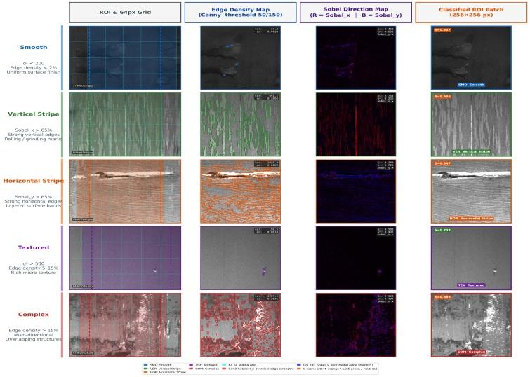
Each row corresponds to a background type (Smooth, Vertical Stripe, Horizontal Stripe, Textured, and Complex), and each column represents a successive processing step: (1) the steel image crop with a 64 px sliding grid and ROI window; (2) the Canny edge density map, which quantifies background complexity via pixel variance and edge density; (3) the Sobel direction map, in which the R channel encodes vertical edge strength (Sobel_x) and the B channel encodes horizontal edge strength (Sobel_y) to determine the dominant surface directionality; (4) the classified 256×256 ROI patch.

Figure4. Representative ROI samples for each defect subtype (top) and background type (bottom) classified in CASDA Stage 1.
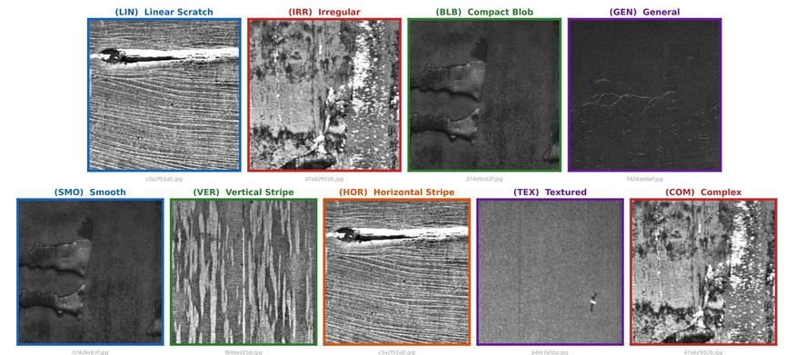
Fig. 4 (1) shows representative ROI samples for each defect subtype: Linear Scratch, Irregular, Compact Blob, and General. Fig. 4 (2) shows representative ROI samples for each background type: Smooth, Vertical Stripe, Horizontal Stripe, Textured, and Complex.

Figure5. Distributions of morphological features.
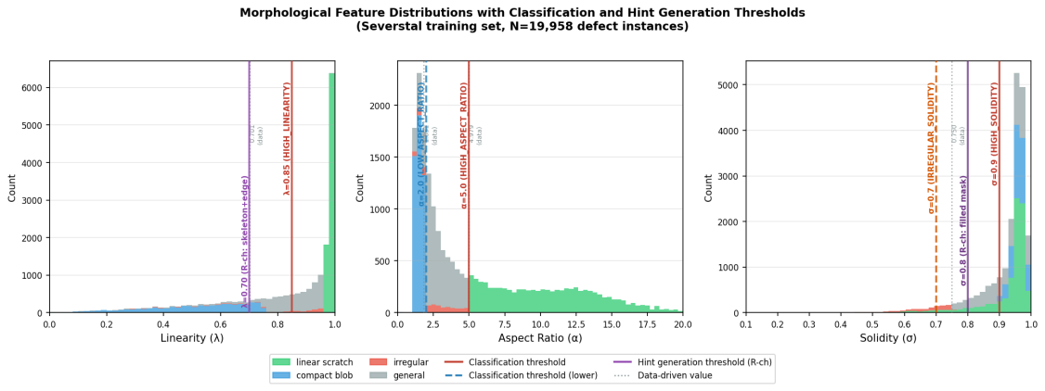
(1) linearity (λ), (2) aspect ratio (α), (3) solidity (σ)
Classification thresholds were derived from the full defect-instance distribution (N=19,958 instances) rather than set manually. For high-boundary thresholds (e.g., linearity λ=0.85, solidity σ=0.9), log-scale Otsu splitting was applied to the feature histograms to identify the natural low-density valley between clusters. For low-boundary thresholds, percentile-based values were used. The close agreement between data-driven values and final paper values confirms that the adopted thresholds follow natural separation boundaries in the data. Fig. 5 illustrates the morphological feature distributions and threshold positions for all defect subtypes.

Figure6. Distribution of per-patch background variance computed from clean background patches.
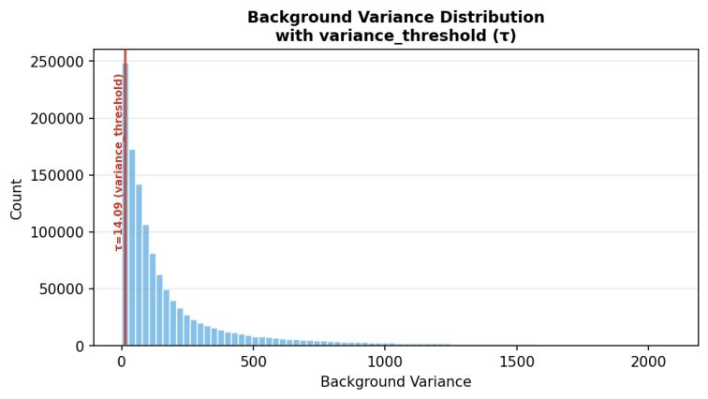
Background suitability thresholds (variance_threshold τ=14.09, edge_threshold ε=0.607) were derived analogously. The variance threshold separates the majority low-variance (smooth steel surface) population from the high-variance tail using log-scale Otsu splitting on the background patch variance distribution (Fig. 6).

Figure7. Distribution of background edge density computed from the same clean background patch set.
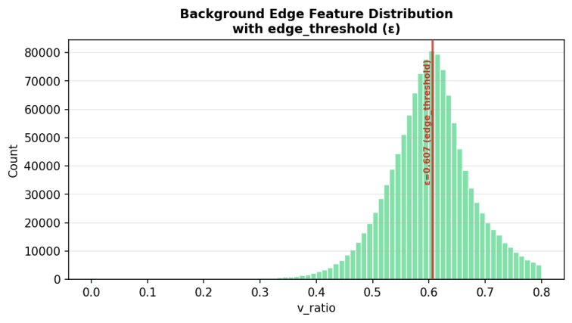
The edge threshold was derived from the edge-density distribution of the same patch set (Fig. 7). Selecting only low-variance, low-edge-density backgrounds directly reduces domain mismatch between composited defect regions and their surroundings, as confirmed by the BGD reduction reported in Section 4.3.

$S_{suitability}=0.5×S_{matching}+0.3×S_{continuity}+0.2×S_{stability}$ | (5)
The suitability score for an ROI was calculated by integrating matching quality, spatial continuity, and background stability.
3.2.2 Stage 2: ControlNet Configuration
The ControlNet model is initialized from lllyasviel/sd-controlnet-canny, built upon the runwayml/stable-diffusion-v1-5 base model, and fine-tuned on the defect ROI dataset for up to 20 epochs using AdamW (lr = 1×10⁻⁵, cosine scheduler with 50 warmup steps) with min-SNR weighting (γ = 5.0) and an effective batch size of 4 (batch size 1, gradient accumulation steps 4) under mixed-precision fp16 training on a Google Colab T4 GPU. The ControlNet conditioning scale was set to 1.0 during training, with early stopping patience of 20 and random seed 42. For inference, 30 denoising steps are applied with a classifier-free guidance scale of 7.5 and a ControlNet conditioning scale of 0.7; generated RGB outputs are converted to grayscale to eliminate VAE decoder color-channel artifacts on single-channel steel surface images.
A 3-channel hint image and a hybrid prompt are configured to enable the ControlNet model to generate both defect-specific and background-specific features [13]. Each channel of the hint image encodes distinct physical characteristics: the R channel reflects the pixel-level geometry of the defect, the G channel reflects surface orientation based on Sobel operations, and the B channel reflects surface roughness through local dispersion [16].
Table 2. Three-channel hint image: channel definitions and generation methods.
Channel | Information | Generation Method | Role
R (Red) | Defect mask | λ>0.7: skeleton+edge  σ>0.8: filled mask  else: edge-based | Pixel-level defect geometry control
G (Green) | Background structure | Vertical: $〖Sobel〗_x$  Horizontal: $〖Sobel〗_y$  Complex: omni-Sobel  Smooth/textured: 0 | Metal grain orientation preservation
B (Blue) | Background texture | 7x7 sliding-window local variance  Smooth: α=0.5 attenuation | Fine-grained surface roughness rendering

Figure8. Three-channel hint image construction in CASDA Stage 2.
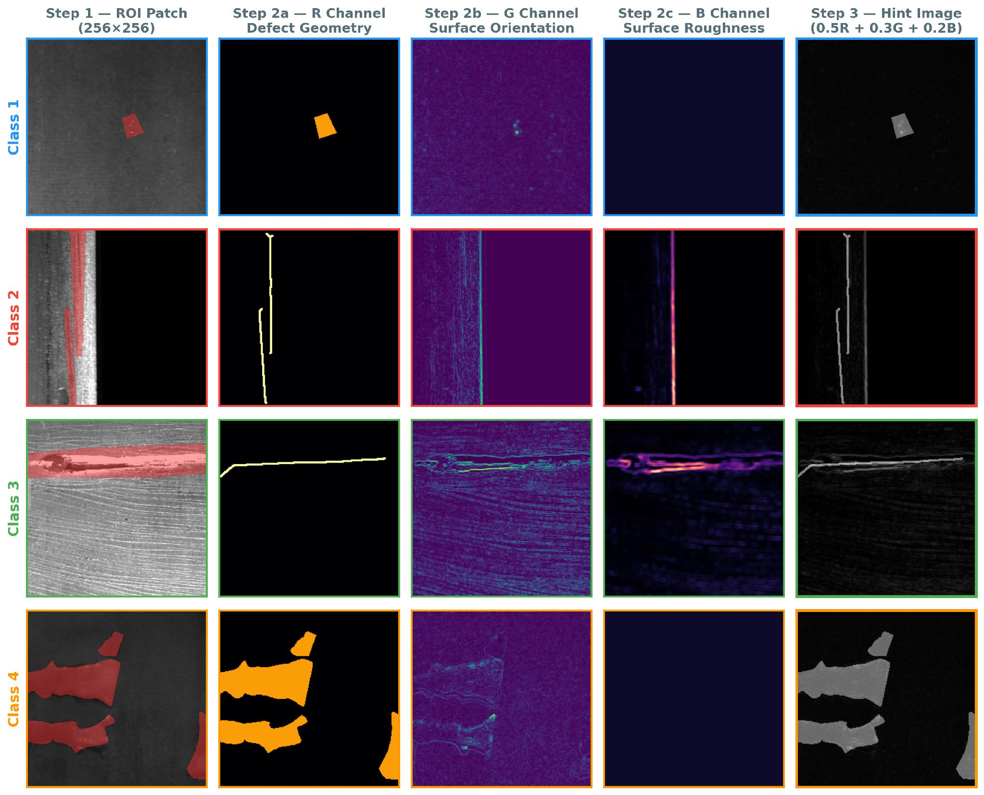
Each row corresponds to a defect class (Class 1 through 4), and each column represents a successive construction step: (1) the ROI patch with defect mask overlay; (2) the R channel encoding defect geometry based on morphological characteristics; (3) the G channel representing surface orientation via directional Sobel filtering per background type; (4) the B channel encoding surface roughness through local variance with a 7×7 kernel; (5) the final hint image (0.5R + 0.3G + 0.2B) used as the ControlNet conditioning input.
Prompts are automatically constructed by concatenating four semantic fields in a fixed template: F1 (defect type), F2 (background type), F3 (directional texture), and F4 (surface condition based on the stability score).

$F_{1} on F_{2} with F_{3} \left( F_{4} \right), Class N$ | (6)
Table 3. Defect type description for F1 prompt component.
Defect Type | Description
linear scratch | a linear scratch defect
elongated | an elongated defect
compact blob | a compact blob defect
irregular | an irregular defect
general | a defect

Table 3 defines the F1 prompt component for each defect subtype, mapping each subtype to a natural-language descriptor that is directly embedded in the generation prompt.
Table 4. Background surface and texture description for F2 and F3 prompt components.
Background | Surface | Texture
smooth | smooth metal surface | uniform texture
textured | textured metal surface | grainy texture
vertical_stripe | vertical striped metal surface | directional texture
horizontal_stripe | horizontal striped metal surface | directional texture
complex_pattern | complex patterned metal surface | multi-directional texture

Table 4 defines the F2 and F3 prompt components for each background type. F2 provides the surface description and F3 provides the corresponding texture modifier. Together, F2 and F3 encode the background substrate characteristics of the ROI into the generation prompt, conditioning the ControlNet model to synthesize defects consistent with the target surface context.
Table 5. Surface condition description based on F4 score
{pristine, well-maintained, clean} s ≥ 0.8
{standard, typical, normal} 0.5 ≤ s < 0.8
{worn, weathered, aged} s < 0.5
As a representative example, a linear_scratch defect on a vertical_stripe background with an F4 stability score of 0.85 produces the prompt: "a linear scratch defect on vertical striped metal surface with directional texture (pristine), class 2."
3.2.3 Stage 3: Context-Based Defect Generation and Synthesis
After extracting background patches from normal images, a composite image is generated by considering the physical alignment between defect characteristics and the background. A compatibility matrix defining the coexistence probability between defect types and background textures is constructed, and the background is probabilistically selected based on this matrix. The defect images generated using ControlNet are then inserted into the selected background, with Poisson blending applied to eliminate boundary discontinuities and ensure visual naturalness.
Table 6. Matching scores between defect subtypes and surface background patterns.
Defect Type | Smooth | Vert. Stripe | Horiz. Stripe | Textured | Complex
Linear scratch | 0.7 | 1.0 | 1.0 | 0.5 | 0.3
Compact blob | 1.0 | 0.5 | 0.5 | 0.7 | 0.6
Irregular | 0.6 | 0.5 | 0.5 | 0.8 | 1.0
General | 0.7 | 0.7 | 0.7 | 0.7 | 0.7
Linear scratch | 0.7 | 1.0 | 1.0 | 0.5 | 0.3
3.2.4 Stage 4: Quality Verification Gate
A quality verification step is performed on each generated sample. A weighted sum score Q is calculated by evaluating morphological consistency (Q_morph), image sharpness (Q_sharp), the presence of artifacts (Q_artifact), and the area ratio (Q_area). Only samples satisfying Q ≥ 0.7 are retained as training data, preventing performance degradation caused by low-quality inputs.
Table 7. Quality metrics for generated image evaluation
Metric | Computation | Weight
$Q_morph$ | if the generated mask type matches, 1.0  if the generated mask type is general, 0.7  if the generated mask type does not match, 0.3 | 0.3
$Q_sharp$ | This value uses the Laplacian variance value, and a value less than 100 indicates blurriness. | 0.3
$Q_artifact$ | if there is no noise, 1.0  if the noise ratio exceeds 10%, 0.0 | 0.2
$Q_area$ | if defects are between 0.1% and 30% of the total area, 1.0  0.5 if defects are too small or too large, 0.5 | 0.2
3.2.5 Stage 5: Dataset Integration
Defect masks are encoded for the selected synthetic images and integrated into the existing training dataset, constructing a final training dataset with improved data diversity and class balance.
3.3. Experimental Procedure
3.3.1 Dataset and Data Split
The Severstal Steel Defect Detection dataset released on Kaggle was used [14]. All images are grayscale with a resolution of 1600×256, reflecting the surface defect characteristics of actual industrial environments. The dataset was partitioned into training, validation, and test sets at a 70:15:15 ratio. The 70:15:15 split was adopted over the 80:10:10 alternative because retaining approximately 1,000 test samples improved the statistical reliability of per-class performance evaluation.
Table 8. Effect of train/validation/test split ratio on segmentation performance
Split Ratio (Train / Val / Test) | Dice Mean | Test Samples
50 / 25 / 25 | 0.6142 | 1,667
60 / 20 / 20 | 0.6256 | 1,334
70 / 15 / 15 | 0.6290 | 1,000
80 / 10 / 10 | 0.6290 | 667
3.3.2 Benchmark Architectures
To evaluate the generality of the proposed augmentation technique, two models with different structural characteristics were selected. YOLO-MFD employs multiscale feature fusion specialized for fine defect detection. EB-YOLOv8 enhances feature representation by incorporating BiFPN (Bidirectional Feature Pyramid Network).
3.3.3 ROI Extraction and Suitability Analysis
Table 9. ROI extraction summary and suitability score distribution.
Metric | Value | Ratio (%)
Total ROIs | 3,247 | 100.0
Mean suitability | 0.68
High quality (≥ 0.7) | 1,990 | 61.3
Acceptable (0.5 ~ 0.7) | 1,022 | 31.5
Excluded (< 0.5) | 235 | 7.2
A total of 3,247 defect regions (ROIs) were extracted from the training dataset. Each ROI was scored using the proposed suitability evaluation metric, yielding an overall average suitability score of 0.68. ROIs were then classified into three groups: the High-quality group (61.3%, 1,990 ROIs) was used as high-quality templates; the Acceptable group (31.5%, 1,022 ROIs) was used selectively; and the Excluded group (7.2%, 235 ROIs) was removed from the template pool.
3.3.4 Augmentation Statistics and Quality Control
Table 10. Synthetic sample quality verification results.
Grade | Score Range | Samples | Ratio (%)
Highest quality | 0.9 ~ 1.0 | 423 | 16.9
Passed | 0.7 ~ 0.9 | 1,652 | 66.1
Failed | 0.5 ~ 0.7 | 358 | 14.3
Discarded | 0.0 ~ 0.5 | 67 | 2.7
Of the 2,500 candidate samples generated by CASDA, 83.0% (2,075 samples) met the quality criteria and were adopted as final training data.
Figure9. ControlNet-generated defect samples produced in CASDA Stage 3.
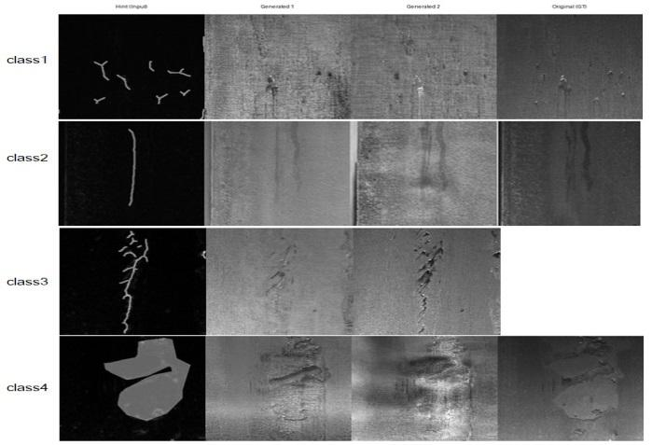
Fig. 9 compares ControlNet-generated defect samples with the original GT under identical hint conditioning. Multiple visually diverse outputs are produced from a single hint input, demonstrating that CASDA expands training data diversity without simple duplication.
Table 11. Per-class data augmentation effect.
Class | Original | CASDA Added | Total | Increase(%)
Class 1 | 2,494 | 756 | 3,250 | 30.3
Class 2 | 247 | 519 | 766 | 110.1
Class 3 | 1,836 | 501 | 2,337 | 27.3
Class 4 | 660 | 462 | 1,122 | 70.0
Total | 5,237 | 2,238 | 7,475 | 42.7
For Class 2, where data sparsity is most pronounced, 519 samples were added to the existing 247, achieving the highest augmentation rate of 110.1%, effectively mitigating the minority class issue. Overall, 2,238 CASDA-generated samples were added to the 5,237 original samples, constructing a final dataset of 7,475 samples. The synthetic data proportion of 42.7% was intentionally maintained to preserve the distributional characteristics of the original data while leveraging the diversity introduced by generated samples.
4. Experimental Results and Analysis
4.1. Performance Evaluation
To assess result stability, all experiments were conducted with two independent random seeds (42 and 456); Tables 12 and 13 report mean ± standard deviation across runs. Due to the small sample size (n = 2), results are presented primarily as descriptive statistics; formal hypothesis tests are included for reference but have limited statistical power. Entries with std = 0.000 indicate that both seeds yielded identical evaluation outcomes, suggesting low sensitivity of those model–group configurations to random seed variation.
Table 12. YOLO-MFD detection performance on the Severstal test set (mean ± std, n = 2 seeds)
Method | mAP@0.5 | Class 1 AP | Class 2 AP | Class 3 AP | Class 4 AP
Baseline (Raw) | 0.1123 ± 0.01 | 0.0172 ± 0.02 | 0.1020 ± 0.05 | 0.1564 ± 0.00 | 0.1736 ± 0.08
Copy-Paste | 0.1036 ± 0.00 | 0.0217 ± 0.00 | 0.0000 ± 0.00 | 0.1973 ± 0.00 | 0.1955 ± 0.00
CASDA | 0.0873 ± 0.00 | 0.0238 ± 0.03 | 0.0561 ± 0.08 | 0.1501 ± 0.01 | 0.1190 ± 0.06
CASDA vs. Raw | −2.50 pp | +0.66 pp | −4.59 pp | −0.63 pp | −5.46 pp
CASDA vs. Copy-Paste | −1.63 pp | +0.21 pp | +5.61 pp | −4.72 pp | −7.65 pp
Table 13. EB-YOLOv8 detection performance on the Severstal test set (mean ± std, n = 2 seeds).
Method | mAP@0.5 | Class 1 AP | Class 2 AP | Class 3 AP | Class 4 AP
Baseline (Raw) | 0.2936 ± 0.00 | 0.1490 ± 0.00 | 0.2548 ± 0.00 | 0.3966 ± 0.00 | 0.3739 ± 0.00
Copy-Paste | 0.2722 ± 0.03 | 0.1479 ± 0.06 | 0.0550 ± 0.00 | 0.4594 ± 0.05 | 0.4266 ± 0.02
CASDA | 0.3196 ± 0.02 | 0.2493 ± 0.01 | 0.2759 ± 0.03 | 0.4287 ± 0.01 | 0.3246 ± 0.07
CASDA vs. Raw | +2.60 pp | +10.03 pp | +2.11 pp | +3.21 pp | −4.93 pp
CASDA vs. Copy-Paste | +4.74 pp | +10.14 pp | +22.09 pp | −3.07 pp | −10.20 pp

As shown in Tables 12 and 13, CASDA achieved an overall mAP@0.5 of 0.3196 for EB-YOLOv8, outperforming both Baseline (Raw) (+2.60 pp) and Copy-Paste (+4.74 pp). Class 1 AP showed the largest gain (+10.03 pp vs. Raw), and Class 2 AP — the defect class most severely affected by data sparsity — improved by +2.11 pp over Raw and +22.09 pp over Copy-Paste. These gains indicate that ControlNet-based context-aware generation produces training samples of higher discriminative value than simple patch reuse. In contrast, CASDA did not improve overall mAP@0.5 for YOLO-MFD (−2.50 pp vs. Raw), and Class 2 AP also decreased (−4.59 pp vs. Raw), though it remained superior to Copy-Paste (+5.61 pp). The high standard deviation observed for YOLO-MFD Class 2 AP (±0.0793 for CASDA; ±0.0495 for Baseline) indicates that results for this metric are highly variable across seeds and should be interpreted with caution.
Due to the small sample size (n = 2 seeds) and evaluation limited to two architectures, statistical power is insufficient to draw definitive conclusions. Descriptive statistics are therefore reported as the primary evidence, and the small experimental scale is acknowledged as a limitation of this study.

4.2. Component-Level Ablation Study
To verify that each CASDA component contributes independently, we conducted a full component-level ablation study on YOLO-MFD. Each variant removes one component at a time while keeping the rest of the pipeline intact.
Each variant disables a single component while keeping the remaining pipeline intact. w/o Seamless Blending replaces Poisson blending with direct paste, leaving a hard-cut boundary at the compositing edge. w/o 3-Channel Hint zeros the G and B channels of the hint image, retaining only the defect mask (R channel) and removing surface-orientation and texture cues from the conditioning signal. w/o Compatibility Matrix disables background-compatibility constraints, selecting backgrounds at random regardless of defect subtype. w/o Context-Aware Prompt substitutes the per-sample structured prompt with a fixed generic string. w/o Quality Gate retains all generated samples regardless of quality score Q, bypassing the Q ≥ 0.7 threshold. Vanilla SD generates defect images using SD v1.5 text-to-image without ControlNet spatial conditioning, serving as both a diffusion-based baseline and a ControlNet-ablation variant.
Table 14. YOLO-MFD ablation study: effect of removing individual CASDA components.
Variant | mAP@0.5 | Δ vs CASDA-Full
CASDA (Full) | 0.0873
w/o Seamless Blending | 0.0610 | −30.1%
w/o 3-Channel Hint | 0.0627 | −28.2%
w/o Compatibility Matrix | 0.0781 | −10.5%
w/o Context-Aware Prompt | 0.0800 | −8.4%
w/o Quality Gate (Pruning) | 0.0941 | +7.8%
Vanilla SD (no ControlNet) | 0.0549 | −37.1%

Removing the Quality Gate raises mAP by inflating recall (recall = 0.112, highest in the table) while precision collapses to 0.368. In industrial defect inspection, false alarms carry direct operational cost; the Quality Gate trades marginal mAP for substantially higher precision, which is the intended behavior.
The Vanilla SD result (−37.1%) confirms that ControlNet conditioning is indispensable: unconstrained text-to-image generation cannot produce spatially aligned defects suitable for augmentation. The 3-Channel Hint (−28.2%) and Seamless Blending (−30.1%) results indicate that these components are not interchangeable with simpler alternatives. Specifically, removing the 3-channel hint (encoding defect-region texture in R, background context in G, and binary mask in B) degrades mAP by 28.2%, indicating that background and texture channels carry information the model cannot recover from prompt alone. The Seamless Blending result (−30.1%) is further supported by the Boundary Gradient Discontinuity (BGD) analysis: CASDA achieves BGD 49.6 ± 24.4 versus Copy-Paste 71.4 ± 26.3, a 30.5% reduction (N=500 per group) (Table 17), directly quantifying the boundary quality improvement that FID/KID/LPIPS as distribution-level metrics do not capture. These results demonstrate that the five key components contribute measurably and that the observed performance gain originates from their specific combination rather than from any individual component independently.

4.3. Synthesis Quality
Table 15. FID and LPIPS-based synthesis quality comparison between CASDA and Copy-Paste per defect class.
Class | FID |  | LPIPS Realism |  | LPIPS Diversity
Class | CASDA | Copy-Paste | CASDA | Copy-Paste | CASDA | Copy-Paste
Class 1 | 296.2 | 104.9 | 0.382 | 0.498 | 0.335 | 0.398
Class 2 | 357.4 | 148.2 | 0.480 | 0.428 | 0.375 | 0.386
Class 3 | 276.8 | 99.1 | 0.493 | 0.484 | 0.491 | 0.412
Class 4 | 292.4 | 91.0 | 0.440 | 0.499 | 0.421 | 0.394
Overall | 228.6 | 61.4 | 0.467 | 0.491 | 0.448 | 0.394
Table 16. KID scores of CASDA-generated samples per defect class (mean ± std).
Class | KID Mean | KID Std
Class 1 | 51.40 | 1.15
Class 2 | 58.83 | 3.13
Class 3 | 33.78 | 0.94
Class 4 | 40.76 | 0.70
Overall | 29.28 | 0.84

Synthesis quality was assessed using FID, KID, and LPIPS; results are summarized in Table 15. For FID, Copy-Paste (61.4) yielded a lower score than CASDA (228.6); however, this reflects the structural property that Copy-Paste directly reuses real patches, making its feature distribution identical to that of the reference set by construction. The FID comparison is therefore included solely to expose this limitation and should not be interpreted as a direct quality comparison.
For LPIPS Realism, CASDA (0.467) outperformed Copy-Paste (0.491) overall, confirming that Poisson blending effectively eliminates boundary artifacts and improves perceptual quality. The improvement was most pronounced in Class 1 (Δ = 0.116) and Class 4 (Δ = 0.060). Class 2 was the sole exception where CASDA was inferior, attributable to the irregular texture of Class 2 defects, which increased ControlNet generation difficulty. Notably, both FID and KID were highest for Class 2 (FID: 357.4, KID: 58.83 ± 3.13), confirming via two independent metrics that the performance gap originates in the generation stage rather than the blending process.
For LPIPS Diversity, CASDA (0.448) exceeded Copy-Paste (0.394), indicating that ControlNet generates structurally varied defect patterns beyond simple patch recombination. These results suggest that synthesis diversity may contribute to the detection performance gains observed in EB-YOLOv8; however, the relationship between generation diversity and downstream detection performance remains architecture-dependent and warrants further investigation.
To complement distribution-level metrics (FID, KID, LPIPS) with a boundary-specific measure, we additionally report Boundary Gradient Discontinuity (BGD). The boundary band B = dilate(M, k) − erode(M, k) is extracted from the binary defect mask M using an elliptical structuring element with kernel size k = 5. BGD is then computed as the mean Sobel gradient magnitude |∇I| = √(Gx² + Gy²) over all pixels within B on the grayscale composited image. Lower BGD indicates smoother gradient transitions at the compositing boundary, reflecting more natural blending at the defect-background interface.

Table 17. Boundary Gradient Discontinuity comparison (N=500 per group, seed=42).
Method | BGD (mean ± std) | Median | N
CASDA (Poisson Blending) | 49.6 ± 24.4 | 44.3 | 500
Copy-Paste (Direct Paste) | 71.4 ± 26.3 | 66.7 | 500

CASDA achieves 30.5% lower BGD than Copy-Paste, with Cohen's d ≈ 0.87 (large effect size). This confirms that Poisson blending smooths gradient transitions at compositing boundaries — the specific limitation that FID/KID/LPIPS as distribution-level metrics do not directly capture. The BGD result is consistent with the ablation finding that removing Seamless Blending reduces mAP by 30.1% (Table 14), providing convergent evidence that boundary quality improvement translates into downstream detection gain.

5. Discussion
The detection performance of benchmark models trained with CASDA-augmented data was evaluated against a raw-data baseline and a Copy-Paste baseline, revealing both the strengths and the architecture-dependent limitations of the proposed framework.
For EB-YOLOv8, CASDA improved overall mAP@0.5 (+2.60 pp vs. Raw) and demonstrated a large gain over Copy-Paste in Class 2 AP (+22.09 pp), the defect class most affected by data sparsity. These results suggest that context-aware synthesis, which conditions ControlNet on both defect morphology and background surface properties, produces more discriminative minority-class training samples than simple patch reuse under the tested settings. In contrast, CASDA did not improve overall mAP@0.5 for YOLO-MFD (−2.50 pp vs. Raw) or Class 2 AP (−4.59 pp vs. Raw), although it outperformed Copy-Paste for Class 2 (+5.61 pp). The high variance in YOLO-MFD Class 2 AP results (std ≈ 0.05–0.08) indicates that performance for this metric is unstable at n = 2 seeds, and the observed differences should not be interpreted as definitive.
Furthermore, the results reveal a clear architecture-dependent sensitivity to CASDA augmentation. EB-YOLOv8 benefited consistently, whereas YOLO-MFD did not. This divergence suggests that multiscale feature fusion architectures such as YOLO-MFD may require augmentation strategies more tightly coupled to their internal feature representation, which remains an open direction for future work.
Regarding statistical inference, formal hypothesis tests (Wilcoxon signed-rank, BH-FDR corrected, α = 0.05) did not reach statistical significance, primarily due to limited statistical power with n = 2 seeds and two architectures. Effect sizes were small for Class 2 improvement (d = 0.47) and negligible for CASDA vs. Copy-Paste overall mAP (d = 0.19). These results are reported transparently; stronger statistical conclusions would require evaluation across more seeds and additional benchmark architectures.
Although the CASDA framework demonstrates meaningful advantages for minority-class augmentation, several limitations remain. To further improve synthesis quality, multi-scale blending and texture-aware compositing techniques should be applied to enhance statistical consistency between synthesized defects and the background. Normalization and brightness correction accounting for lighting conditions are planned to improve visual naturalness. Future work should establish a universal pipeline applicable to diverse industrial sectors including PCBs, wood, and carpets, and verify generalizability across additional backbone architectures.
6. Conclusion
Overall, this study proposes CASDA, a context-aware steel defect augmentation framework that classifies defect morphology and background surface characteristics, generates customized defect images via ControlNet, and synthesizes them into training data through Poisson blending. The framework achieved a quality validation pass rate of 83.0% and increased the number of Class 2 training samples — the rarest defect class — by 110.1%. These results suggest that context-aware synthesis produces more discriminative minority-class samples than simple patch reuse under the tested settings. Multi-seed evaluation (seeds 42, 456) over two benchmark architectures showed that CASDA improved overall mAP@0.5 and Class 2 AP for EB-YOLOv8 (+2.60 pp and +2.11 pp vs. Raw, respectively), and outperformed Copy-Paste in Class 2 AP for both architectures (EB-YOLOv8: +22.09 pp; YOLO-MFD: +5.61 pp). Nevertheless, YOLO-MFD did not show overall improvement with CASDA (−2.50 pp vs. Raw), indicating architecture-dependent sensitivity that warrants further investigation. Statistical significance tests did not reach α = 0.05 under the current experimental scale, and this limitation is acknowledged. Specifically, CASDA's benefit is most pronounced on architectures optimized for fine-grained industrial inspection (EB-YOLOv8), while general-purpose detectors (YOLO-MFD) show limited gain, indicating that the interaction between augmentation strategy and backbone feature representation is a key factor to consider in practice. Future work should focus on improving synthesis reliability through more sophisticated blending and post-processing techniques, and on extending the framework to a general-purpose pipeline applicable to diverse industrial sectors including PCBs, wood, and carpets.

Author Contributions: Conceptualization, H.-J.H. and I.-Y.M.; methodology, H.-J.H. and I.-Y.M.; software, H.-J.H. and I.-Y.M.; data curation, H.-J.H. and I.-Y.M.; investigation, H.-J.H. and I.-Y.M.; writing—original draft preparation, H.-J.H. and I.-Y.M.; writing—review and editing, H.-J.H. and I.-Y.M.; supervision, I.‐Y.M. All authors have read and agreed to the published version of the manuscript.
Funding: Not applicable.
Institutional Review Board Statement: Not applicable.
Informed Consent Statement: Not applicable.
Acknowledgments: The authors would like to thank the editors and reviewers for constructive suggestions and comments that helped improve the quality of the article.
Conflicts of Interest: The authors declare no conflict of interest.
References
- Rippel, O.; Merhof, D. Anomaly Detection for Automated Visual Inspection: A Review. Technologien für die intelligente Automation. 2023. DOI: 10.1007/978-3-662-66769-9_1.
- Hütten, N.; Gomes, M. A.; Hölken, F.; Andricevic, K.; Meyes, R. Deep Learning for Automated Visual Inspection in Manufacturing and Maintenance: A Survey of Open-Access Papers. Applied System Innovation. 2024. DOI: 10.3390/asi7010011.
- Bergmann, P.; Fauser, M.; Sattlegger, D.; Steger, C. MVTec AD A Comprehensive Real-World Dataset for Unsupervised Anomaly Detection. International Journal of Computer Vision. 2021. DOI: 10.1007/s11263-020-01400-4.
- Zavrtanik, V.; Kristan, M.; Skočaj, D. DRAEM—A Discriminatively Trained Reconstruction Embedding for Surface Anomaly Detection. Proceedings of the IEEE/CVF International Conference on Computer Vision (ICCV). 2021. DOI: 10.1109/ICCV48922.2021.00836.
- Shorten, C.; Khoshgoftaar, T. M. A Survey on Image Data Augmentation for Deep Learning. Journal of Big Data. 2019. DOI: 10.1186/s40537-019-0197-0.
- Goodfellow, I.; Pouget-Abadie, J.; Mirza, M.; Xu, B.; Warde-Farley, D.; Ozair, S.; Courville, A.; Bengio, Y. Generative Adversarial Nets. Advances in Neural Information Processing Systems (NeurIPS). 2014. DOI: 10.48550/arXiv.1406.2661.
- Ho, J.; Jain, A.; Abbeel, P. Denoising Diffusion Probabilistic Models. Advances in Neural Information Processing Systems (NeurIPS). 2020. DOI: 10.48550/arXiv.2006.11239.
- Redmon, J.; Divvala, S.; Girshick, R.; Farhadi, A. You Only Look Once: Unified, Real-Time Object Detection. Proceedings of the IEEE Conference on Computer Vision and Pattern Recognition (CVPR). 2016. DOI: 10.1109/CVPR.2016.91.
- Ronneberger, O.; Fischer, P.; Brox, T. U-Net: Convolutional Networks for Biomedical Image Segmentation. Medical Image Computing and Computer-Assisted Intervention (MICCAI). 2015. DOI: 10.1007/978-3-319-24574-4_28.
- Ruff, L.; Vandermeulen, R.; Görnitz, N.; Binder, A.; Müller, E.; Kloft, M. Deep One-Class Classification. Proceedings of the International Conference on Machine Learning (ICML). 2018. DOI: 10.48550/arXiv.1802.06360.
- Han, H.J.; Moon, I.Y.; Research on Object Detection Model-Based Equipment Defect Detection Method. Journal of Advanced Navigation Technology, 2025, 29(6), 859–866. DOI: 10.12673/JANT.2025.29.6.859.
- Dwibedi, D.; Misra, I.; Hebert, M. Cut, Paste and Learn: Surprisingly Easy Synthesis for Instance Detection. Proceedings of the IEEE International Conference on Computer Vision (ICCV). 2017. DOI: 10.1109/ICCV.2017.328.
- Zhang, L.; Rao, A.; Agrawala, M. Adding Conditional Control to Text-to-Image Diffusion Models. Proceedings of the IEEE/CVF International Conference on Computer Vision (ICCV), 2023, pp. 3836–3847. DOI: 10.1109/ICCV51070.2023.00355
- Severstal Steel Defect Detection. Kaggle Competition, 2019. Available online: https://www.kaggle.com/competitions/severstal-steel-defect-detection
- Frangi, A. F.; Niessen, W. J.; Vincken, K. L.; Viergever, M. A. Multiscale Vessel Enhancement Filtering. Medical Image Computing and Computer-Assisted Intervention (MICCAI). 1998, 130, 130–137. DOI: 10.1007/BFb0056195.
- van der Walt, S.; Schönberger, J. L.; Nunez-Iglesias, J.; Boulogne, F.; Warner, J. D.; Yager, N.; Gouillart, E.; Yu, T. scikit-image: Image Processing in Python. PeerJ. 2014, 2, e453. DOI: 10.7717/peerj.453.
- Rosenfeld, A.; Kak, A. C. Digital Picture Processing, 2nd ed.; Academic Press: New York, USA, 1982.
- Ngan, H. Y. T.; Pang, G. K. H.; Yung, N. H. C. Automated Fabric Defect Detection—A Review. Image and Vision Computing. 2011, 29, 442–458. DOI: 10.1016/j.imavis.2011.02.002.
- Weimer, D.; Scholz-Reiter, B.; Shpitalni, M. Design of deep convolutional neural network architectures for automated feature extraction in industrial inspection. CIRP Annals. 2016; Synthetic data augmentation for surface defect detection and classification using deep learning. Journal of Intelligent Manufacturing. 2022, 33, 1–17. DOI: 10.1007/s10845-020-01710-x
- Li, H.; Liu, Y.; Liu, C.; Pang, H.; Xu, K. A Few-Shot Steel Surface Defect Generation Method Based on Diffusion Models. Sensors. 2025, 25(10), 3038. DOI: 10.3390/s25103038
- Guclu, E.; Akin, E. Enhanced defect detection on steel surfaces using integrated residual refinement module with synthetic data augmentation. Measurement. 2025. DOI: 10.1016/j.measurement (pii: S0263224125004956)

